# Overview

This document contains the necessary information to build the device.

Contents

Overview 1

Maker Checklist 3

Maker To Do List 3

Items to Give to User 3

Tool List 4

Customization Guide 4

Assembly Guide 4

Required Components 4

Required Tools 5

Required Personal Protective Equipment (PPE) 5

Step 1: Flip over the button 6

Step 2: Remove the screws 6

Step 3: Open the button enclosure 7

Step 3: Prepare a press button 7

Step 4: Trim the button topper post 8

Step 5: Glue the new button in place 8

Step 6: Strip a 3.5mm cable 9

Step 7: Drill cable tie holes 9

Step 8: Drill the cable hole 10

Step 9: Thread the cable through the outer ring 10

Step 10: Solder the cable to the button 11

Step 11: Secure the cable 11

Step 12: Replace the button topper 12

Step 13: Replace the foam ring 12

Step 14: Reassemble the button 13

Step 15: Replace the screws 13

Step 16: Replace the adhesive feet 14

Step 17: Final Test 14

Testing 16

Troubleshooting 16

Switch tester not activating but message playing 16

Switch tester always active 16

Message not playing but switch activating 16

Message not playing and switch tester not activating 16

# Maker Checklist

This list provides an overview of the steps required to build and deliver the device.

## Maker To Do List

* Read through the Assembly Guide to become familiar with required components, tools, supplies, and safety gear and overall assembly steps.
* Talk to User about customization options (e.g., color, any special requests, etc.)
* Order hardware components
* Gather tools, supplies, and safety equipment.
* Assemble the device
* Test device
* Print “User Guide”

## Items to Give to User

* Assembled, tested device
* “User Guide”

# Tool List

* Flat head screwdriver or similar prying tool
* Phillips head screwdriver
* 1/8th inch drill bit and drill
* Hot glue gun
* Soldering iron
* Switch Tester or multimeter with continuity testing function

# Customization Guide

Choosing the colour of the button is the only customization available for this build.

# Assembly Guide

## Required Components

|  |  |
| --- | --- |
| Labeled diagram of all the components used to build the device | **BOM**   1. Message Playback button 2. Cable tie 3. Press button 4. 3.5mm audio cable |

## Required Tools

* Flat head screwdriver or similar prying tool
* Phillips head screwdriver
* 1/8th inch drill bit and drill
* Cable tie
* Hot glue gun
* Soldering iron
* Switch Tester

## Required Personal Protective Equipment (PPE)

* Safety glasses

### Step 1: Flip over the button

Flip the button over, exposing the base. Removing the batteries is not necessary but is recommended.

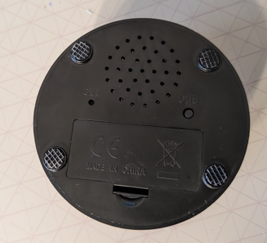

### Step 2: Remove the screws

Using a flat head screwdriver or other object, pry off the stick on rubber feet to expose the four screws and remove them with a screwdriver.

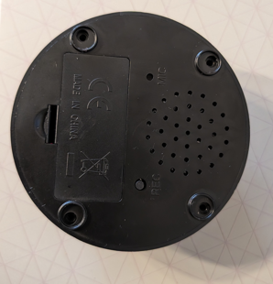

### Step 3: Open the button enclosure

Flip the button back over and press the button topper. This should cause the bottom of the button to come off and reveal the PCB inside.

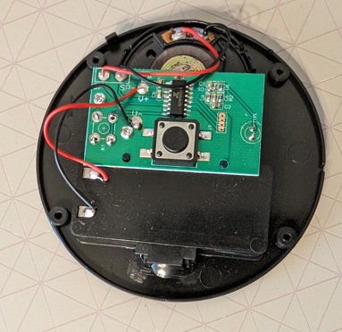

### Step 3: Prepare a press button

Take a press button, and bend the prongs to the side. Flip it over and trim off the two bumps on the bottom so it can lie flat.

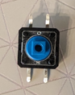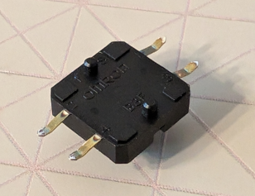

### Step 4: Trim the button topper post

Take the button topper, and cut a length off the post that is the same height as the press button. Err on the side of not cutting enough, more can be cut off later if it is still too long but it is difficult to add more if you cut too much.

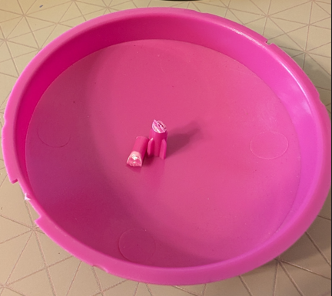

### Step 5: Glue the new button in place

Place a small dot of hot glue, roughly the size of the head of a pin, on the flat of the button soldered onto the PCB. Place the other button on the flat on top of the hot glue. Be careful not to use too much, otherwise it can interfere with the functionality of the PCB button

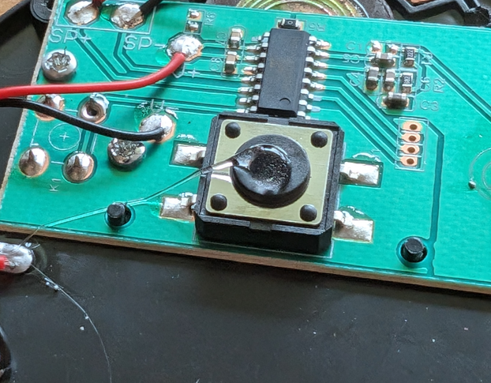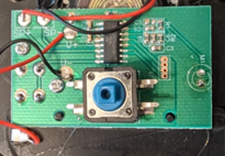

### Step 6: Strip a 3.5mm cable

Take a 3.5mm cable and cut off one end to roughly 5 ft unless otherwise requested by the user, stripping it to expose the wires. Strip half a centimeter of insulation from each of the wires. Plug the cable into a switch tester, and touch pairs of wires together until you find which pair cause the light on the switch tester to turn on when they are shorted. Trim all the other wires that are not used.

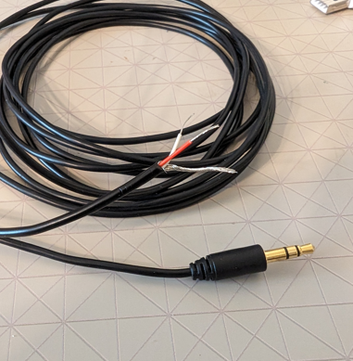

### Step 7: Drill cable tie holes

Using a 1/8th inch drill bit, drill two holes on the base separated by roughly 1/8 inch. Placing the holes near the locating slot on the base makes it easier to align these holes with the hole drilled in the next step.

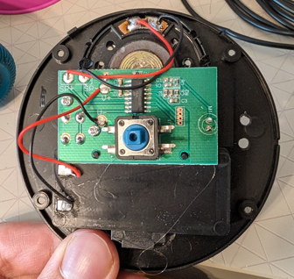

### Step 8: Drill the cable hole

Place the top ring back onto the base, lining up the slot so the base fits properly. Drill a 1/8th inch hole in the outer ring where the ring starts to narrow, lined up between the previous two holes drilled.

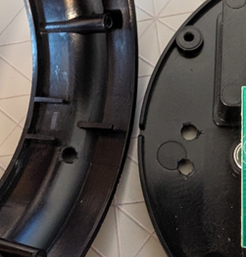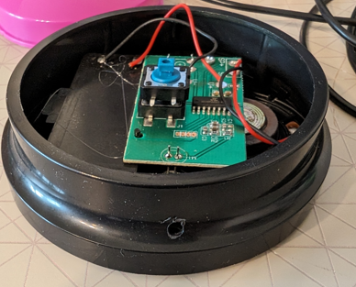

### Step 9: Thread the cable through the outer ring

Take the 3.5mm cable and thread it through the hole on the outer ring.

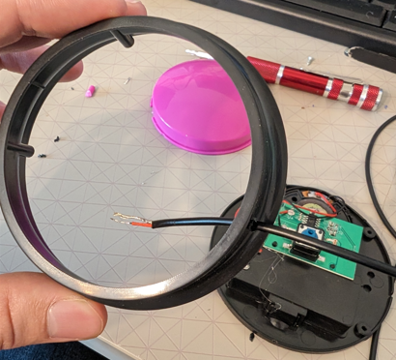

### Step 10: Solder the cable to the button

Place the ring onto the base, and solder the two cable wires onto the two tabs on one side of the button. If the outer ring is not in place, it is possible to solder the wires to the button in a way that makes the ring impossible to put on later.

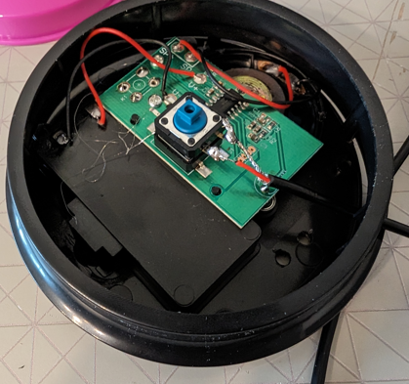

### Step 11: Secure the cable

Take a cable tie, and using the two holes drilled in step 7, cable tie the cable in place to prevent the cable from putting strain on the button.

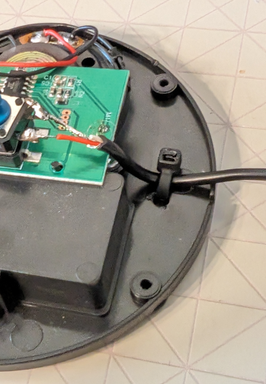

### Step 12: Replace the button topper

Place the button topper back in the outer ring.

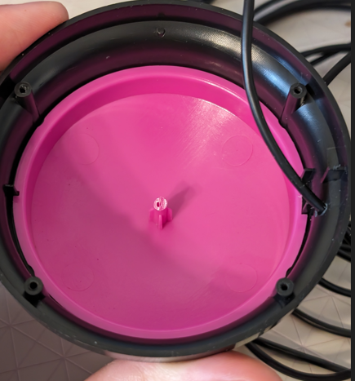

### Step 13: Replace the foam ring

Place the foam ring back around the pillar in the middle of the button topper.

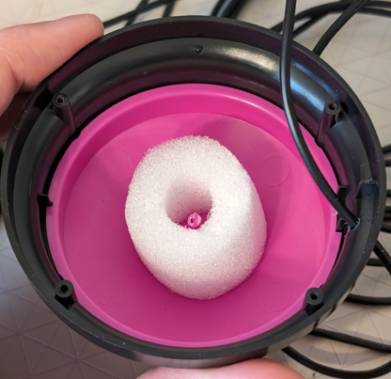

### Step 14: Reassemble the button

Place the outer ring onto the base. At this point, test the switch using a switch tester to make sure that the button topper post is the correct size. If the post is too long, the switch will be always active, and the button topper will not press down. If this happens, slightly trim the button topper post.

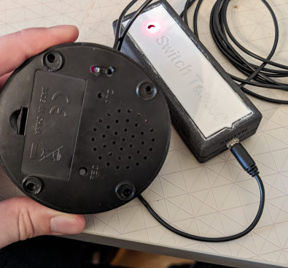

### Step 15: Replace the screws

If the button is working correctly, use a screwdriver to put the screws back in the base.

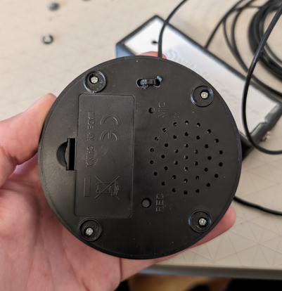

### Step 16: Replace the adhesive feet

Place the adhesive pad back over the screws.

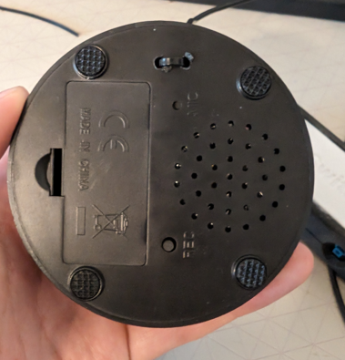

### Step 17: Final Test

Flip the switch back over and test it that it works.

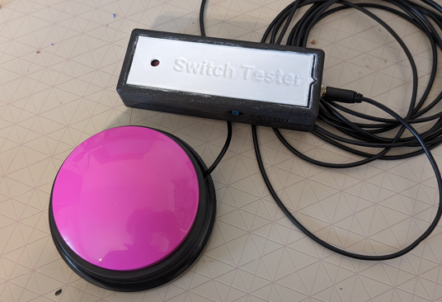

# Testing

Connect the switch tester to the switch and press the button. If everything is working correctly, the switch tester should turn on, and the switch should play the recorded message.

## Troubleshooting

### Switch tester not activating but message playing

Check that the connections between the button and the 3.5mm cable have not been damaged. Check that the wires in the cable soldered to the button are the correct ones needed to activate the switch tester, as in step 6.

### Switch tester always active

Check that the post of the button topper is not too long and always pressing down the button stack. If it is, trimming the post slightly until it is not pressing the stack should fix the issue.

### Message not playing but switch activating

Check that there are working batteries in the switch, and that a message has been recorded. Check that the button soldered to the PCB has not had any of the leads shorted.

### Message not playing and switch tester not activating

Check that the post on the button topper has not been trimmed too short and is still able to press the button stack. If it has been cut too short, try using the hot glue to glue a small shim to the post to lengthen it.